Exam 1

This is an open book exam. You can use any means available to answer the questions, except getting the answers from your fellow students (you can consult with one another, but do your own work!)

The exam is due at 8:30 am on Friday, November 13. You can hand in a paper copy or send a pdf or docx as an email attachment to tony.lowry@usu.edu; it’s up to you.

Please show all of your work.

Note that 6640 students have one extra question.

Good Luck!

Name:____________________________________________

1. [5 pts] What is stress (choose one)?

A 2nd order tensor that describes deformation
A 4th order tensor that is equivalent to the spring constant in Hooke’s Law.
A scalar that describes body forces.
A 2nd order tensor that gives surface forces per unit area.

2. [5] At what sort of plate boundary do we find the largest earthquakes (choose one):

Divergent
Convergent
Transform

3. [15] Consider the following strain tensor, in x₁ = east, x₂ = north, x₃ = down coordinates:

Find the eigenvalues and eigenvectors:

If the strain was generated by a P-wave traveling in a 6400 m/s velocity medium, what is its ray parameter p? What direction is it traveling?

4. [15]. For a deep focus earthquake with an epicentral distance of 50° sketch ray paths for the 3 seismic phases PcP, ScP, PcS, in a single cross-section through the Earth. The ray paths must have the proper location relative to each other. Fermat’s Principle applies here. Note: Deep focus means something to a seismologist!

5. [20] The seismogram below, from Palisades NY, records an earthquake that occurred in Iran (a distance of 110°).
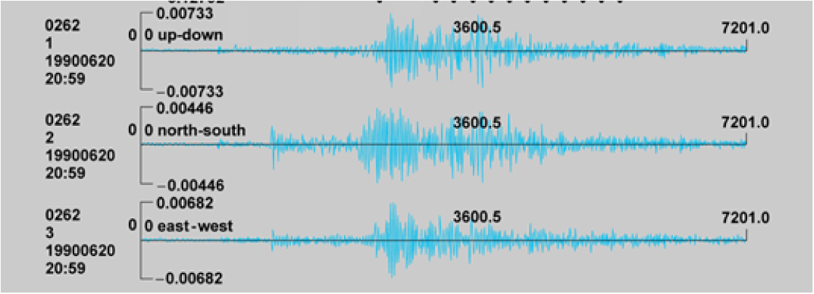

Pick and identify as many phases as you can from the seismogram. For each pick you make, mark the arrival on whichever seismogram the phase appears most strongly, and indicate the approximate time of arrival, the phase, and the basis for your identification. Note that the time is indicated above in seconds following the earthquake (i.e. the seismogram ends at 7201 s = 2hr, 1 sec after the event).

6. [10] Use Huygen’s principle to determine wavefronts at 1 millisecond intervals for downward propagation of the planar wavefront (dashed line) shown. Sketch in the next five wavefronts.
wavefront at time 0
3 m
6 m
V₁ = 1000 m/s
V₂ = 3000 m/s

Draw (using a different color) the rays associated with these wavefronts at the left and right sides of the figure and three equally-spaced points in between. Do these rays conform to Snell’s Law? Why or why not?

7. [10] The displacement potentials for a planar P-wave traveling horizontally east are given by
φ = A exp[–i(ωt – k_{x} x)]
where A is 100 [mks units], ω is 1 Hz, and k_{x} = 0.00025 m⁻¹.

What is the compressional velocity of the medium? Assuming a Poisson solid and a density of 2450 kg m⁻³, what is the shear rigidity? The shear velocity?

What are the amplitudes of the displacements? Of the accelerations?

Derive the strain tensor (as a function of t and x) for the wave.

If time t is ten seconds and distance x is 12 km, what is the phase?

8. [10] Consider a layered medium with layers consisting of (i) a thickness of 200 m and velocity 2400 m/s at the top; (ii) a thickness of 400 m and velocity 3500 m/s below that; (iii) a thickness of 18000 m and velocity 6500 m/s below that; (iv) a thickness of 8000 m and velocity 7200 m/s below that; underlain by (v) an 8100 m/s mantle.

Now consider a ray that leaves the surface with a take-off angle-of-incidence of 20°. How long will it take for the ray to return to the surface?

How far will it have traveled along the Earth’s surface?

What were the angles of incidence θ and surficial apparent velocities c_{x} in each of the layers?

Next consider a ray that leaves a point source with angle of incidence of 0°, and the wave in that direction has displacement amplitude 0.1 m. Assuming no anelastic attenuation, what are the displacement amplitudes of the reflections that return to the surface from each of the layer boundaries if the densities are (i) 2200 kg m⁻³; (ii) 2400 kg m⁻³; (iii) 2700 kg m⁻³; (iv) 2900 kg m⁻³; and (v) 3330 kg m⁻³?

9. [20] Using the file PREM.dat on the website, write a matlab m-script to model both the time and distance of a P-wave traveling from the surface downward and back up to the surface, assuming a 1D, Cartesian Earth. Note there are two complicating factors: (1) You will need to code an algorithm to find the turning depth, z_{p}, of the wave for the given ray parameter p, & (2) PREM’s velocity is not piecewise constant but changes linearly between nodes. Ideally, you could evaluate the integral for a linear increase in velocity and code it into matlab (but it’s fine if instead you want to use the mean velocity in each layer instead).

- Include your m-script with the assignment.

- Find (by trial and error) the ray parameter for the ray that arrives as close as possible to 500 km distance from the source. What is the velocity at its turning depth?

- What was the travel-time for the ray arriving at 500 km distance?

10. [5] Describe a topic you would like to see covered at some point during the remainder of the course.

11. [20 pts; 6640 students only] Describe as fully as possible (in one to two single-spaced pages) your plans for your semester project. Your description should include the nature and source of the data you plan to use, a description of the analysis tools you intend to employ, the goals of the project, and the context in which you think this may advance your thesis or dissertation research.

